Netpoker
Start the game 2
Create game 2
Join game 2
Playing the game 2
Turns 2
Messages 2

Start the game
You start the game eith the exe file. When the program has started you have the chose to create a game or to join a game. If you create a game you will have control over the game, if you join a game the person you connect to will control the game.

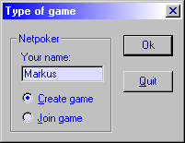
Create game
You create a game by selecting “Create game” in the dialogbox and write your name in the editbox. The press “OK”. The game is now running you just have to wait for players to connect. When you are satisfied with the number of players connected you can start the game by pressing “New game”.
The game ends by the creator only after the players has thrown their cards away and a new turn may be played.

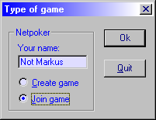
Join game
To join a game this game must have been created and I must be in the same network (i.e. internet) as your computer is.
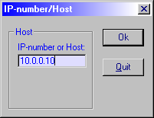
To join a game chose “Join game” in the dialogbox write your name in the editbox, then press “Ok”. Now you have to know the name och the ip number of the computer you wish to join a game at. Write in that name or ip-number and press “Ok”. Now you are connected to the game but you must wait until the creator of the game starts a new game.

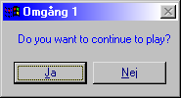
Playing the game
Playing the game is like playing a normal game of poker. Everyone throws 1-5 cards and when everyone has done that. everyone retrieves new cards. This goes on until the creator of the game decides to end the game.

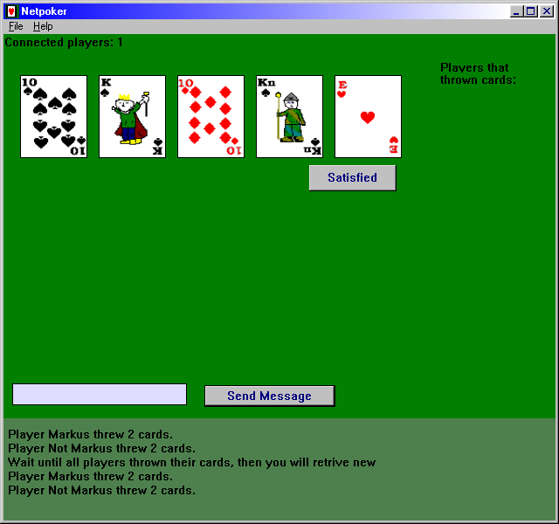
Turns
The number of turns(throws of cards) is decided by the creator of the game.

Messages
During the game you can communicate with the other players by writing messages in the little with box beside “Send message”. To send the message you press “Send message”, then all players will retrieve the message at bottom of the screen.

